Economics of Climate Adaptation in Barisal, Bangladesh: Hands-on climada

Dr. David N. Bresch, Global Head Sustainability, Swiss Re

Lea Müller, Climate Change Specialist, Swiss Re

## Background

The city of Barisal is located in southern Bangladesh on the northern shore of the Bay of Bengal. It is 140 km south of Dhaka and is the headquarters of both the Barisal Division and the Barisal District. The metropolitan city has ~300'00 inhabitants (with surroundings ~400'000) and lies 1 m above sea level. Barisal port is one of the biggest river ports in Bangladesh at the Kirthankhola River. Barisal is a rice producing centre of Bangladesh. As the city is surrounded by rivers its nickname is Venice of the East. The economy is mainly based on agriculture (rice production) and fishing.

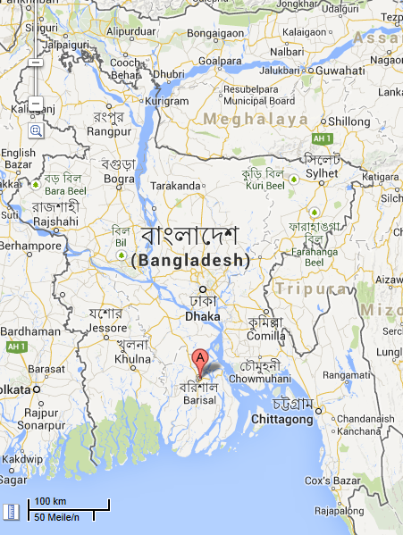

Figure 1: The city of Barisal is located in southern Bangladesh on the northern shore of the Bay of Bengal. It is 140 km south of Dhaka and is the headquarters of both the Barisal Division and the Barisal District. Source: Google maps.

Bangladesh has a tropical climate and is exposed to tropical cyclones that form in the North Indian Ocean. Tropical cyclone Sidr was the strongest named cyclone in the Bay of Bengal, with peak 1-minute sustained winds of 260 km/h a category 5 hurricane on the Saffir-Simpson Scale. It made landfall in Bangladesh on November 15, 2007, causing at least 3500 deaths and 450 million USD damage and 650'000 people evacuated. The damage in Bangladesh was extensive and included flattened tin shacks, houses and schools blown away and enormous tree damage. The storm surge peak was over 5 meters (16 feet). The triangular shape of Bengal Bay funnels high surges into the apex of the triangle where Bangladesh sits, and the shallow bottom of the bay allows extraordinarily high storm surges to pile up.

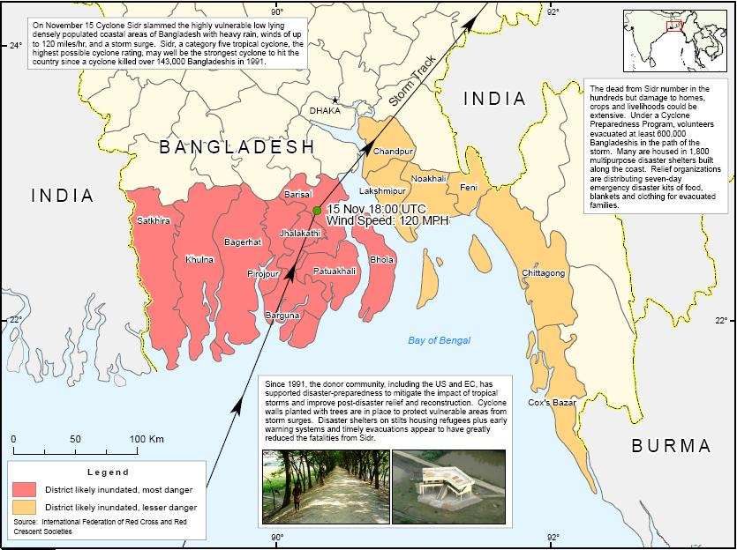

Figure 2: Tropical cyclone Sidr was the strongest named cyclone in the Bay of Bengal, with peak 1-minute sustained winds of 260 km/h a category 5 hurricane on the Saffir-Simpson Scale. Source: Wikipedia, <http://en.wikipedia.org/wiki/Cyclone_Sidr#cite_note-NOAA-21>

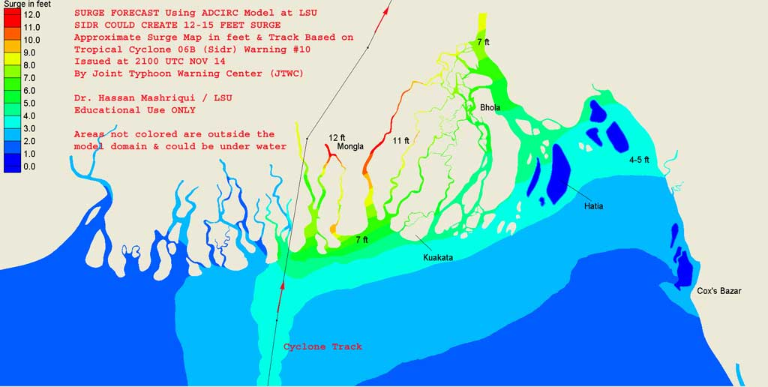

**Barisal**

Figure 3: Storm surge calculation of tropical cyclone Sidr that make landfall in Bangladesh 15 November 2007. Source: Wikipedia, <http://en.wikipedia.org/wiki/Cyclone_Sidr>

## Assets

Bangladesh is a lower-middle income, medium-sized economy located in South Asia. Bangladesh has a population of 159.90 million people. In 2012 Bangladesh's GDP was USD 123 billion[1]. Bangladesh's GDP grew at 6.10% in 2012. GDP per capita, in purchasing power-adjusted dollar terms, is USD 2039.

Bangladesh's economy is predominantly services-based. Agriculture accounts for 18% of GDP and employs 48% of the population. Manufacturing and industry accounts for 29% of GDP and employs 15% of the population. Services accounts for 43% of the GDP and employs 35% of the population. Bangladesh's total exports in 2007 were USD 13.14 billion while its total imports were USD 17.62 billion.

Table 1: GDP figures for Bangladesh and the city of Barisal1

|  |  |  |  |  |
| --- | --- | --- | --- | --- |
| *Year* | *GDP Bangladesh (USD)* | *Increase factor* | *GDP Barisal*  *(USD)* | *Part of*  *Bangladesh* |
| 2010 | 100 billion | 1 |  |  |
| 2012 | 113 billion | 1.12 to 2010 | 3.49 billion | 3.1 % |
| 2030 | 221 billion | 1.96 to 2012 | 6.85 billion | 3.1% |

|  |  |
| --- | --- |
| Figure 4: Asset distribution in Bangladesh based on night light intensities on ~9 km resolution. | Figure 5: Assets in the region of Barisal only (total 3.49 billion USD in 2012, and 6.85 billion USD in 2030). |

## Damage functions

A damage function describes how the asset responds to a given wind intensity. The damage function consists of two curves which put wind intensity in relation to mean damage degree and percentage of affected assets for a certain class of assets. See Figure 6 and Figure 7 for example damage functions that we use in today's exercise.

|  |  |
| --- | --- |
| Figure 6: Mean damage degree in relation to wind intensity for 4 different asset classes. Mean damage degree is maximum 50%. | Figure 7: Percentage of affected assets in relation to wind intensity. Percentage of affected assets reaches 100% for curve type 1, 3 and 4, whereas for curve type 2 the maximum percentage of affected assets is only 50%. |

## Hazard: tropical cyclones in the Bay of Bengal

Bangladesh lies at the North Indian basin where tropical storms form during April to December with peaks in May and November. The majority of the storms form between 10 and 30 degrees of latitude away of the equator and 87% forms no further away than 20 degrees north or south. Tropical cyclones in the North Indian basin are tracked through Joint Typhoon Warning Center (JTWC) Advisories[2]. Best track data are publicly available from 1979 to 2012 and can be downloaded through the Unisys Weather Homepage[3].

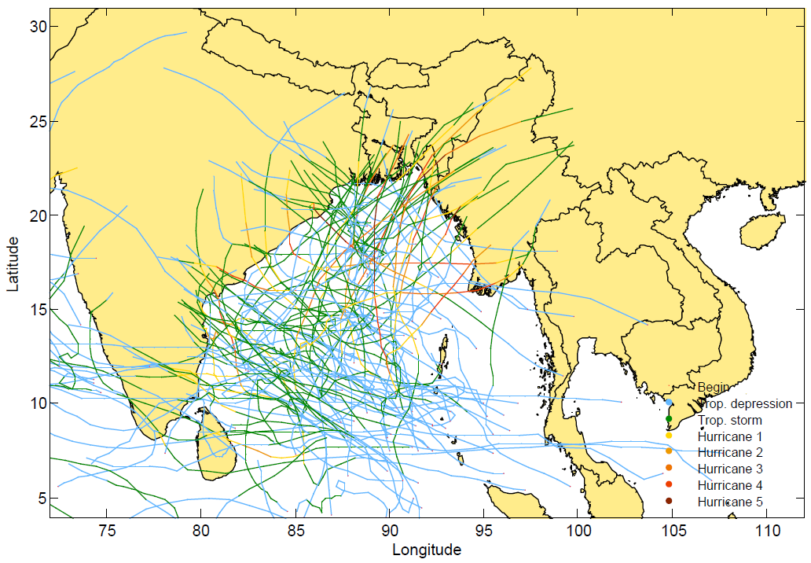

Figure 8: Historical tropical cyclone tracks in the Bay of Bengal from 1979 to 2012.

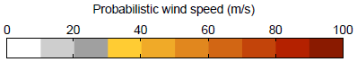

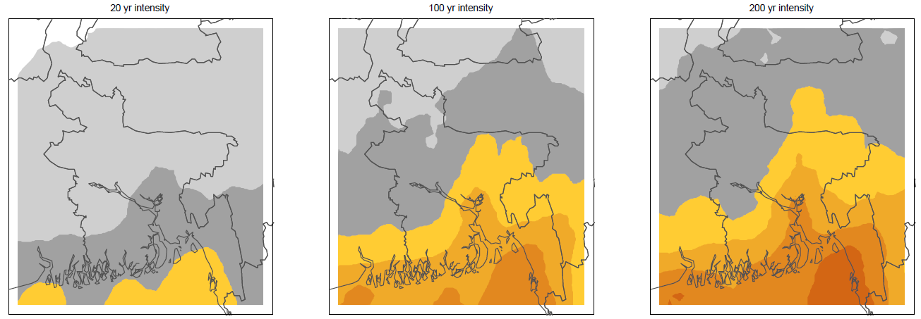

Barisal

Barisal

Barisal

Figure 9: Wind intensity map for different return periods in Bangladesh, today's climate.

### Climate change scenario for tropical cyclones in the Bay of Bengal

The Special Report on Extremes (SREX)[4] by the IPCC published in April 2012 states that the confidence of a long-term increase in tropical cyclone activity is low. However it is likely (high confidence level, 66% likelihood) that tropical cyclone related rainfall rates increase between 3 and 37% until the end of the century (Knutson et al., 2010). There is also a likely increase in mean maximum wind speed by 2 to 11% globally by the end of the century (Bengtsson et al., 2007, Knutson et al., 2008; Sugi et al., 2009; Bender et al., 2010, Emanuel, 2007). In the Atlantic as it is the most studied basin scientists found out that is more likely than not (50% likelihood) that the frequency of the most intense storms (Saffir-Simpson category 4 and 5) will substantially increase (by 80%) (Bender et al., 2010, Knutson et al., 2008)

## Hands-on climada

### Technicalities

In essence, climada (climate adaptation) is a probabilistic damage model with the capability to calculate a climate adaptation cost curve. climada is implemented in MATLAB®[5], which is a [numerical computing](http://en.wikipedia.org/wiki/Numerical_analysis) environment and [fourth-generation programming language](http://en.wikipedia.org/wiki/Fourth-generation_programming_language). MATLAB® is a commercial software that needs to be installed in order to run climada. The climada package is open-source and can be redistributed and used in source and binary forms, with or without modification, as long as it retains the copyright notice[6].

The climada package is a folder that can be copied to any desired location, e.g. my documents or C:\TEMP. In this exercise you find climada in C:\TEMP\climada. The core modules have interfaces to spreadsheet applications such as Microsoft Excel and Open Office spreadsheets. The folder contains three subfolders, namely code, data and docs (Figure 10) as well as the startup file (startup.m). Double click on the startup file to start MATLAB® and to begin this hands-on session. In docs you find more information, e.g. the climada manual, this word-document and the license. The data folder is again structured with five different folders, which contain the relevant input and result files. The folder entities contains the assets, including location and damage functions of assets. The result folder will contain mat-files of expected damage sets (e.g. EDS.mat) and the impacts of measures (e.g. m_entity_hazard.mat).



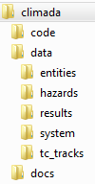

Figure 10: climada folder structure and the startup file that starts MATLAB. In this exercise we have saved the climada folder in the TEMP folder on the hard drive (C). You can copy the climada folder to any desired location on your computer.

### climada demo version

Decide on implementation of adaptation measures

Choose a climate change scenario

Set an economic growth rate

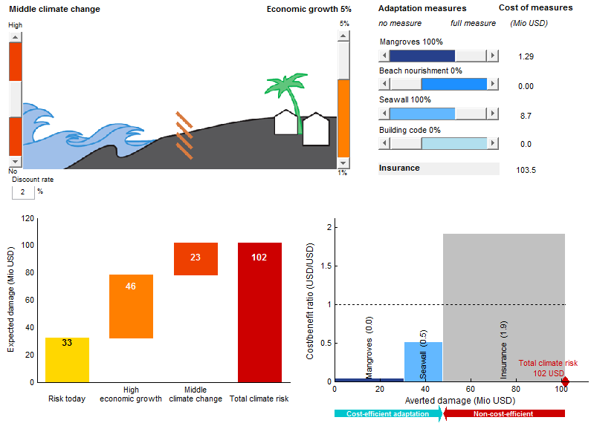

Combine adaptation measures and see if these are cost-efficient (a cost/benefit ratio below 1). In the above example the implementation of a full seawall can reduce almost 20 Mio USD while costs arise only to 9 Mio USD.

Observe the total climate risk and its key drivers, e.g. for 5% growth and middle climate change scenario the total climate risk increases from today 33 to 102 Mio USD per year.

Figure 11: The climada demo[7] implements the concept of total climate risk and cost-effective adaptation in an interactive way: The user can experiment with all relevant factors (sliders, top) and instantly observe the effect – both on risk (measured by expected damage, graph on the left) and the basket of adaptation measures (shown as adaptation cost curve, graph on the right).

### Asses the risk: calculate the risk today and the total climate risk in 2030

On the basis of the assets in the region of Barisal and the storm event sets we can calculate the event damage set (EDS). The code computes the event damage for every storm of the probabilistic hazard set as the sum of the damage at all centroids.

Type EDS=climada_EDS_calc and choose the appropriate entity and hazard to calculate the following risks. Save each of the event damage sets separately.

* In order to calculate the risk today, type EDS(1)=climada_EDS_calc, in the first dialog box select entity_Barisal and in the second dialog box select TCNIO_hazard_Bangladesh.
* In order to calculate the risk in 2030 based on economic growth only, type EDS(2)=climada_EDS_calc, in the first dialog box select entity_Barisal_2030 and in the second dialog box select TCNIO_hazard_Bangladesh.
* In order to calculate the total climate risk in 2030, type EDS(3)=climada_EDS_calc, in the first dialog box select entity_Barisal_2030 and in the second dialog box select TCNIO_hazard_Bangladesh_2030.

Following the calculation of the EDS we can plot the event damage as a function of return periods. The so called occurrence damage exceedance frequency curve (DFC) can be plotted for one or multiple event damage sets (EDS). If EDS not given, EDS is prompted for. Multiple EDS can be selected (press and hold shift to select multiple EDS:mat files).

Type climada_EDS_DFC(EDS) and input the three event damage sets to obtain the graph below (Figure 12).

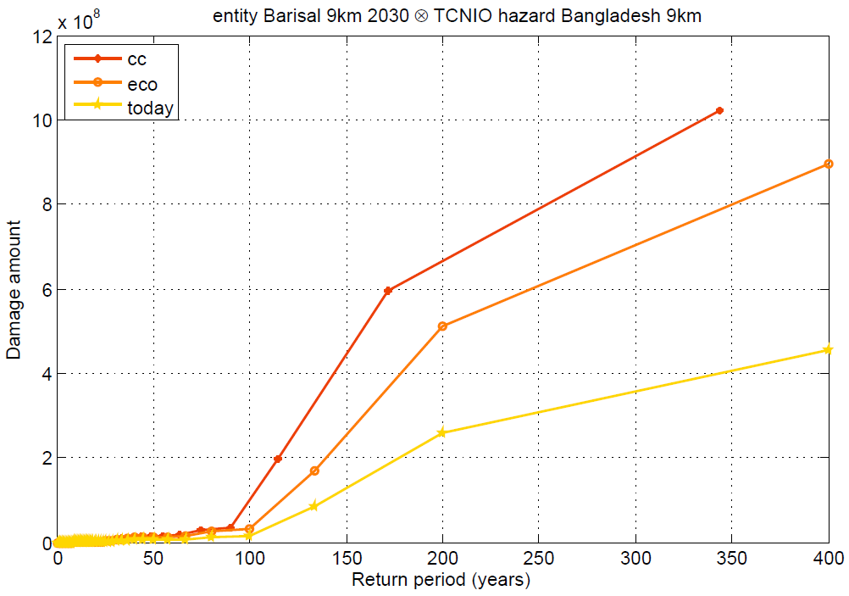

Figure 12: Damage frequency curves for Barisal today (yellow), including economic growth until 2030 (orange) and including climate change until 2030 (red).

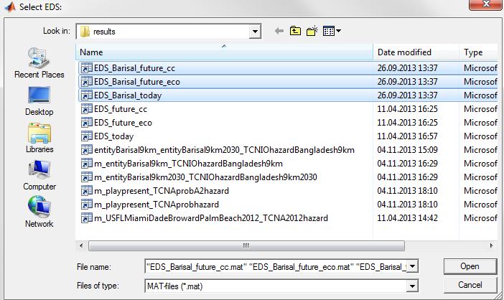

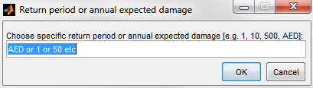To plot the waterfall graph (Figure 13) type climada_waterfall_graph(EDS(1),EDS(2),EDS(3)) and in the dialog box type AED for annual expected damage. If you want to see the graph on the basis of a specific return period, choose the required year. In the waterfall graph shows today's expected damage, the additional risks due to economic growth and climate change and the total climate risk in 2030.

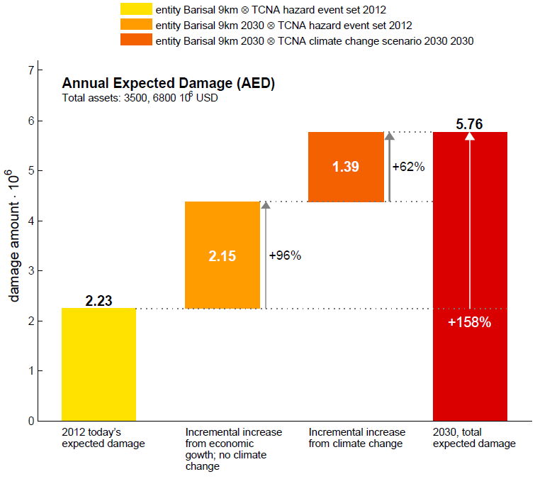

Figure 13: Annual expected damage today (yellow), incremental increase from economic development until 2030 (orange), incremental increase from climate change (dark orange) and total expected damage in 2030 (red).

### Address the risk: Barisal's adaptation measures and the adaptation cost curve

We have compiled example adaptation measures for Barisal ranging from bamboo platforms, mangrove conservation to wind-resistant roofs and cross-bracing of houses. Please note that these measures are example measures and are indicative only. Find out more about the specific adaptation measures at the end this chapter. Cost of measures are indicative only as they are very roughly estimated based on number of people, houses and costs of measure per house.

Type measures_impact=climada_measures_impact to calculate the damage reduction of the adaptation measures based on a given hazard. Notice that the measures are also automatically saved as mat-file in …\climada\data\results\m_entity_hazard.mat.

* First calculate the impact of the measures (measures_impact) for today's assets (entity_Barisal) and today's climate (TCNIO_hazard_Bangladesh) and skip the reference scenario (press cancel).
* 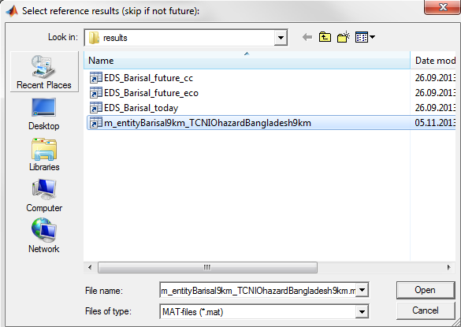Second calculate the impact of the measures for the future scenario (measures_impact_future) for the assets in 2030 (entity_Barisal_2030) and the climate change scenario (TCNIO_hazard_Bangladesh_2030). Here we need the reference results (m_entityBarisal9km_TCNIOhazardBangladesh9km) as a basis. The results file (impact of measures) is again automatically saved as (m_entityBarisal9km2030_TCNIOhazardBangladesh9km2030)

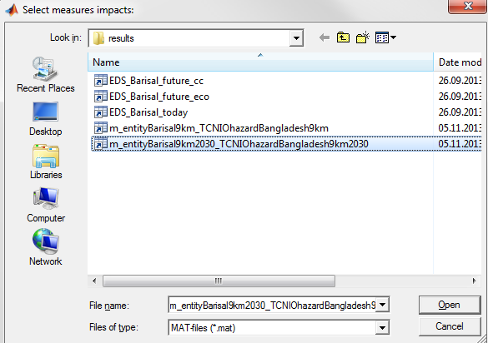Type climada_adaptation_cost_curve to create the adaptation cost curve that is based on the impact of measures on the total climate risk. Select m_entityBarisal2030_TCNIOhazardBangaldesh2030 as the result file.

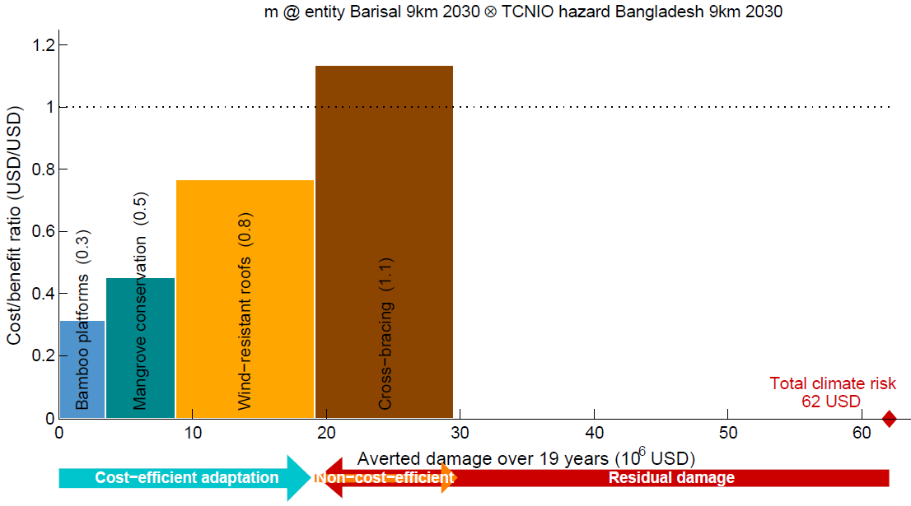

Figure 14: Adaptation cost curve for Barisal for climate change scenario and economic growth until 2030. Bamboo platforms and mangrove conservation are cost-efficient measures; whereas wind-resistant roof is in the neutral range and cross-bracing of house structures implies slightly more investments than averted damage. For more background information on adaptation measures see the end of this chapter.

### Adaptation measures for Barisal

This chapter looks at possible adaptation measures for the city of Barisal. All numbers are indicative only as they are based on a first very rough estimation.

In many parts of Bangladesh, low-income households build a house of natural building materials within Tk 2000-3000 (1000 Tk ~= 13 USD, 26 to 39 USD). The loan from credit programs is at least Tk 10,000 or more, an unaffordable option for many. These programs tend to benefit somewhat better-off people (ADPC, 2005)[8].

Table 2: List of measures, associated costs and impact on hazard and vulnerability. Costs are indicative only.

|  |  |  |  |  |  |  |  |  |
| --- | --- | --- | --- | --- | --- | --- | --- | --- |
| *Adaptation measure* | *Cost*  *(USD)* | *Hazard intensity impact* | *Hazard high frequency cutoff* | *MDD impact*  *a* | *MDD impact b* | *PAA impact a* | *PAA impact b* | *Damage-functions map* |
| **Bamboo platforms** | **1'097'600** | 0 | 0 | **0.997** | **-0.005** | 1 | 0 | nil |
| **Cross-bracing** | **11'840'000** | 0 | 0 | **0.99** | **-0.015** | 1 | 0 | nil |
| **Wind-resistant roofs** | **7'992'000** | 0 | 0 | 1 | 0 | 1 | 0 | **1to3** |
| **Mangrove conservation** | **2'368'000** | **-0.8** | 0 | 1 | 0 | 1 | 0 | nil |

Table 3: Estimation of number of inhabitants and houses (indicative only)

|  |  |  |  |  |  |
| --- | --- | --- | --- | --- | --- |
| *# of inhabitants today* | *Population increase until 2030\** | *# of inhabitants 2030* | *# of people per house* | *# of houses* | *# of additional houses/infrastructure* |
| 400'000 | 1.96 | 784'000 | 4 | 196'000 | 100'000 |

* Estimation based on economic growth from the World Bank

Table 4: Estimation of costs of adaptation measures based on number of houses in the region of Barisal (indicative only)

|  |  |  |  |
| --- | --- | --- | --- |
| *Adaptation measure* | *Total cost*  *(USD)* | *Cost per house (USD)* | *Fraction of people* |
| Bamboo platforms for low-income bamboo houses | 1'097'600 | 7 | 0.8 |
| Cross-bracing for all houses | 11'840'000 | 40 | 1 |
| Wind-resistant roofs for all houses | 7'992'000 | 27 | 1 |
| Mangrove conservation | 2'368'000 | 10 | 0.8 |

#### Bamboo platform inside a bamboo house to serve as refuge area

In Bangladesh as in most of the tropics traditional housing is rural housing, designed by the user in his spare time, based on low investment, local materials, combined with the assistance of relations, friends and neighbours (Rashid et al., 2007). Different kinds of houses are developed in different regions of Bangladesh such as mud house, bamboo house, stilts house and timber hours. The majority of houses feature walls of straw or bamboo with a roof made out of burnt-tiles or corrugated iron sheets. Straw or bamboo roofs are also in use.

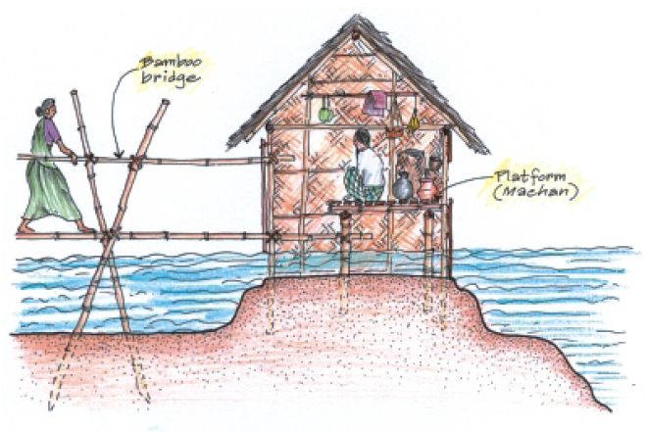

Figure 15: Bamboo house in flood-prone areas can have built-in wooden/bamboo platforms that normally are used as storage space, but during flood event serves as a raised refuge area.

Source: ADPC, 2005.

#### Cross-bracing for bamboo-framed house

Cross-bracing increases stability and wind-resistance of bamboo-framed houses.

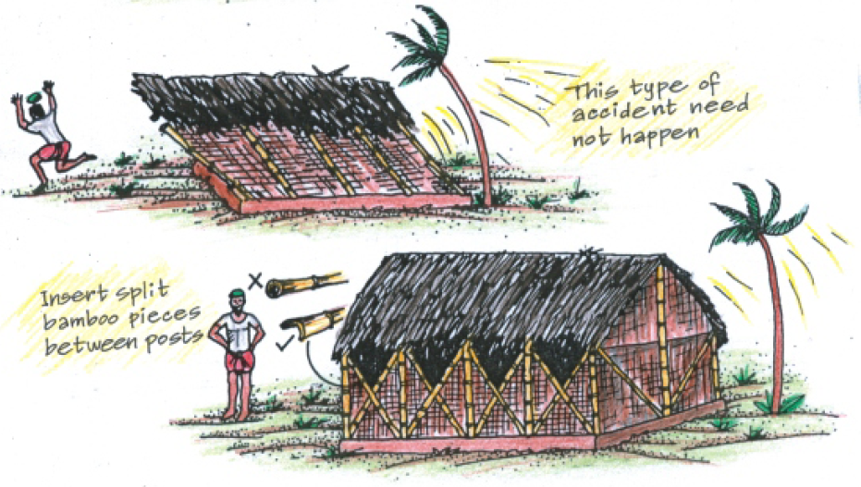

Figure 16: Cross-bracing increases stability and wind-resistance of bamboo-framed houses. Source: ADPC, 2005.

#### Wind-resistant roofing

A wind-resistant roof is based on an aerodynamic form. This includes a roof-pitch between 30° and 40° that reduces uplift, and a hipped roof instead of a gable roof.

|  |  |
| --- | --- |
| Figure 17: A roof pitch between 30° and 40° reduces uplift and suction by wind. Source: ADPC, 2005. | Figure 18: A hipped roof (top) is more wind-resistant than a gable roof (bottom). Source: ADPC, 2005. |

#### Mangrove conservation

Mangrove forests provide protection to coastal areas from tsunamis and cyclones. Mangroves serve as a biological shield breaking the waves during large storms and mitigate the effects of storm surge.

As a result of their intricately entangled above-ground root systems, mangrove communities protect shorelines during storm events by absorbing wave energy and reducing the velocity of water passing through the root barrier (Mazda, 1997). Wave energy may be reduced by 75 per cent in the wave's passage through 200 metres of mangrove (Massel 1999). McIvor et al., 2012 suggests that wave height can be reduced by between 13 and 66% over 100 m of mangroves.

Mangrove covered shorelines are less likely to erode, or will erode significantly more slowly, than unvegetated shorelines during periods of high wave energy. Protecting mangroves sustains natural protection, and is less expensive than seawalls and similar erosion control structures, which can increase erosion in front of the structure and at adjacent properties

(Source: Wikipedia, <http://en.wikipedia.org/wiki/Ecological_values_of_mangrove> ).

McIvor et al., 2012: Reduction of wind and swell waves by mangroves

<http://www.wetlands.org/LinkClick.aspx?fileticket=fh56xgzHilg%3D&tabid=56>

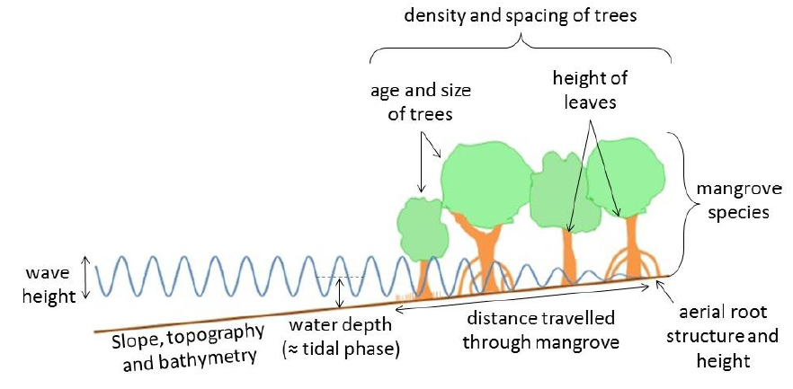

Figure 19: Mangroves attenuate waves depending on the above seen factors. Source: McIvor et al., 2012.

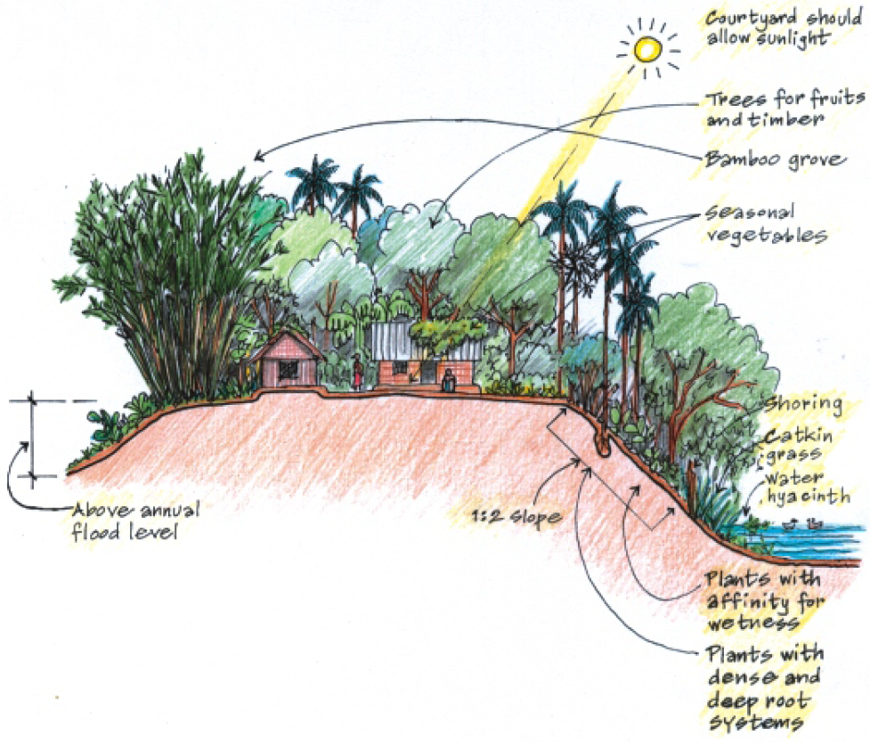

Figure 20: Landscaping/planting trees protects soil from erosion and ideally consists of trees with a dense root system that can withstand drought and flood. Source: ADPC, 2005.

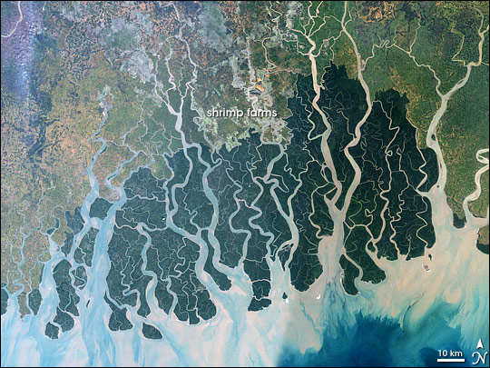

Figure 21: Sundarbans mangrove forest in southwestern Bangladesh and southeastern India is on a low-lying plain and part of the Mouths of the Ganges. As the largest remaining tract of mangrove forest in the world it is protected as a National Park. The satellite image shows the Sundarbans deep green, surrounded to the north by agricultural lands (lighter greens), towns (tan), and streams in blue. Source: Nasa, <http://climateimc.org/en/original-news/2013/01/16/mangrove-forests-threatened-climate-change-sundarbans-bangladesh-and-india>

##### Difficulties with mangroves

While the mangroves are now hailed a success, planting them wasn’t. In fact they had to plant the mangroves three times because they weren’t adequately protected when in the early growing stages from people fishing in the area. In response they created specific routes for the fishing boats. The project managers also say communicating the potential benefits of the mangroves was key to their success. They talked to the men in the local committee, the women in the local union and then helped support an educational programme in the school focusing on disaster preparedness and on the benefits of the mangroves for the children and their families using educational resources with pictures such as the one posted on this blog (Source: <http://www.iied.org/vietnam-mangroves-break-waves-help-people-dai-hop-commune-break-even>).

##### CO2 mitigation effect of mangroves

Coastal strips cover 6% of the earth's forests, but they make up a massive 20% of the deforestation carbon. The mangrove forests also sequester each year a large amount of 'blue carbon'.

## Appendix

### climada centroids

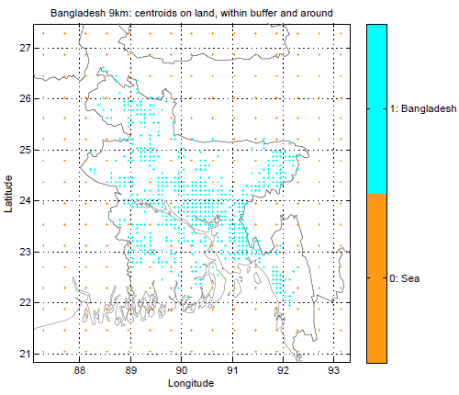

Figure 22: Centroids in and around Bangladesh.

### Literature on climate change in Bangladesh

It is estimated by researchers of the School of Oceanographic Studies, Jadavpur University, that the annual rise in sea level from 3.14 mm recorded till the year 2000 more than doubled to about 8 mm in 2010.

Australian CSIRO scientists recently reported a trend in the East Indian Ocean for Cyclone frequency declining while intensity increasing.

Cyclone frequency declining while intensity increasing across Australia: CSIRO

<http://takvera.blogspot.ch/2011/12/cyclone-frequency-declining-while.html>

The increasing intensity of the strongest tropical cyclones, Elsener et al., 2008

<http://www.nature.com/nature/journal/v455/n7209/full/nature07234.html>

Cyclone intensity in North Indian Ocean linked to increasing air pollution

<http://takvera.blogspot.com.au/2012/01/cyclone-intensity-in-north-indian-ocean.html>

1. The World Bank, <http://data.worldbank.org/indicator/NY.GDP.MKTP.CD>
2. Joint Typhoon Warning Center (JTWC) Advisories, <http://www.usno.navy.mil/JTWC/>
3. Unisys Weather, <http://weather.unisys.com/hurricane/>

   Best track archive for the North Indian ocean, <http://weather.unisys.com/hurricane/n_indian/tracks.nio>
4. Special Report on Managing the Risks of Extreme Events and Disasters to Advance Climate change Adaptation (March 2012), <http://www.ipcc-wg2.gov/SREX/images/uploads/SREX-All_FINAL.pdf>, page 185ff.
5. MATLAB® <http://www.mathworks.com/products/matlab/>
6. climada license, [www.iac.ethz.ch/edu/courses/master/modules/climate_risk/license.txt](http://www.iac.ethz.ch/edu/courses/master/modules/climate_risk/license.txt)
7. Start the interactive demo by entering **climada_demo** in the MATLAB command window. You only have to set the MATLAB path to .../climada and in the MATLAB command window, type **startup** prior to type **climada_demo**.
8. Asian Disaster Preparedness Center (ADPC), 2005: Design and Construction of Housing for Flood-Prone Rural Areas of Bangladesh.

   <http://www.adpc.net/audmp/library/housinghandbook/handbook_complete-b.pdf>

   Rashid et al., 2007: Traditional House of Bangladesh.

   <http://unaus.eu/pdf/A014.pdf>

   Roy et al., 200?: An Experimental Study Towards Development of Wind Resistant Rural Homes in Bangladesh.

   <http://salekseraj.com/C06.pdf>